Internal Technical Report No: AU.AM.CSA.2015-CA498: 19

A Template Based Checking Algorithm to Compare the Project Documents based on a Score Generation Scheme

Submitted by

Nikhil Dominic - AM.EN.P2MCA14019
Vineeth G.K - AM.EN.P2MCA14028

Guided by

MG Thushara, Faculty, CSA

MASTER OF COMPUTER APPLICATIONS



AMRITA VISHWA VIDYA PEETHAM
AMRITA SCHOOL OF ENGINEERING, AMRITAPURI, 690525

January - 2015

AMRITA VISHWA VIDYA PEETHAM
AMRITA SCHOOL OF ENGINEERING, AMRITAPURI, 690525

BONAFIDE CERTIFICATE

This is to certify that the project report entitled “A Template Based Checking Algorithm to Compare the Project Documents based on a Score Generation Scheme” submitted by Nikhil Dominic & Vineeth G.K in partial fulfillment of the requirements for the award of the degree of Master of Computer Applications is a bonafide record of the work carried out under our guidance and supervision at Amrita School of Engineering, Amritapuri.

SIGNATURE SIGNATURE

Manjusha Nair M MG Thushara
Project Coordinator Project Guide
Asst.Professor Faculty
CSA Department CSA Department

This project report was evaluated by us on 4th January 2016

INTERNAL EXAMINER EXTERNAL EXAMINER
(Name and signature) (Name and Signature)

DECLARATION

We, Nikhil Dominic & Vineeth G.K hereby declare that this Internal Technical Report, entitled “A Template based Checking Algorithm for Score Generation, tagging and clustering of Project Documents”, done at Amrita School of Engineering, Amritapuri, Kollam is a record of original work done by us under the guidance of Thushara MG, Department of Computer Science and Applications, Amrita School of Engineering, Amritapuri and that this work has not formed on the basis for the award of any degree/diploma/associate ship/fellowship or a similar award, to any candidate in any University, to the best of my knowledge.

Amritapuri
4/01/2016

Nikhil Dominic

Vineeth GK

ACKNOWLEDGEMENT

First of all we would like to thank the Almighty for giving us the courage to complete this project work successfully. We express our gratitude to our respected Chancellor Sri Mata Amritanandamayi Devi for being a backbone to achieve this project successfully.
We thank our college Amrita School of Engineering, Amritapuri for providing us with all the facilities like laboratories, library, 24X7 internet accesses etc.
We express our deep gratitude to Dr.SN Jyothi, Principal, Amrita School of Engineering, and Amritapuri for their support
We are extremely thankful to Mr. Ramachandran Kaimal, Chairman, Department of Computer Science and Applications, Amrita School of Engineering, Amritapuri for his primary support throughout the project.
We are extending thankfulness to Mrs. Ani R, Vice-Chairman, Department of Computer Science and Applications, Amrita School of Engineering, Amritapuri for his primary support throughout the project.
We are grateful and thankful to Mrs. MG Thushara, Faculty, Amrita School of Engineering, Amritapuri, Internal Guide who supported and guided us throughout the project period.

Table of Contents

Abstract 02

Introduction 02

Literature Review 02

Methodology 03

Results and Analysis 08

Conclusion & Future Work 12

References 13

List of Figures

Figure 1 XML Schema 05

Figure 2 First Interface 08

Figure 3 Generated Output 09

Figure 4 Generated XML 10

Figure 5 Uploading Document 10

Figure 6 Document View 11

Figure 7 Output with Score 11

Figure 8 Sample Search Result 12

Abstract
This paper describes features and methods for document comparison with templates and score generation. In this paper the uploaded documents is categorized based on the research area. Every project documents are designed based on templates. Some of the standard format which is accepted worldwide are User Requirements Specification (URS), System Requirements Specification (SRS), System Test Cases (STC), User Acceptance Testing (UAT), and Defect Track Log (DTL). The approach described here exploits the results of recent progress in information extraction to compare a document with its template and calculates a score. Clustering the documents based on the template is an important task for applications that analyze the template structure and need clean training data.

Introduction
Software projects are part of every computer science under graduate as well as post graduate courses. In each academic year more than 50 projects are carried out. The project deliverable documents must adhere a specific standard template. The template differ from each genre of document types. Genre of documents like System Requirements Specification (SRS), System Test Cases (STC) etc. For a project mentor it is impractical to manually verify the numerous project documents uploaded. We propose this template based checking algorithm to ensure the correctness and valuate the project documents. In the field of information retrieval, extraction of salient words as well as the meta-data is now possible. The focus of the work described here is to provide a method for checking whether a document follows its template format [1][2][3]. Here we read the document and extract the document properties and generate XML files correspondingly for both document and also the template. That is at the end the comparison is between the XML.
Literature Review:
Comparing two documents for similarity is a crucial process. Similar related projects are done based on the layout similarities in two documents [2]. These visual similarities are categorized and analyzed in vector methods. The document is converted into vector co-ordinates. These vectors are used in different distance measures. Hidden Markov Models (HMM) to model different classes of layouts. Using this sequence of vertical regions are identified. Each region have consistent horizontal layout features like number of columns and widths and position of each column and variable heights [2]. Here in this project, apart from the visual similarities we are comparing the text and the text properties.
Comparing two XML files done on similar projects [8] are based on the Depth First Search (DFS) method. Each nodes in the XML are first traversed and the child nodes are stored into a stack. Backtracking is done at each branch ends. Tag encoding functions helps to figure out the tree structure of the file there by allowing the parser to traverse in depth without missing any nodes. A tag encoding function is a function that associates a number with each tag instance appearing in the document [8]. Here in this project an XML file is treated in a similar way. Each nodes represents a heading. The child nodes represents different properties of the heading and its contents.
With tagging, the readers of a Web or a database can relate a word or with that of resource in the whole repository. The resource can then be found by searching for that tag or a combination of different tags. Tagging becomes popular, it will face challenges, including ambiguity of tags and tag spam. Tagging is now widely used in social networking sites like Facebook to relate similar posts. In twitter the tweets are co-related and each similar tweets helps in dynamically generating new tags for a specific category of tweets [9]. Some of these sites allow the end user to define his own tags to link the posts with similar other tags.
Silverstein, Henzinger, Marais, and Moricz studied the basic nature of search engine users and examined query logs that included one billion search queries and 285 million user sessions. The result is as follows.
1. Users generally enter short queries
2. Users don’t usually modify their queries
3. Users don’t usually look at more than the first 10 results.
Information retrieval (IR) performance can be enhanced with a defined database or system that fetches information from the Internet or a repository with more relevant to the topic.
Semantic improved search results. It adds context data to the tags correspondingly. Content and the tags are added to the ontology at the time of information storing. Also evaluates all tags before the content is submitted. If a tag found to be exists in the ontology, all hypernyms of the tag are displayed to the user. Hypernyms provide the synonym for the tag. This allows the user to choose the exact meaning of the content. [10]

Methodology
TEMPLATE BASED CHECKING

Based on the standard templates, project documents like System Requirements Specification (SRS), System Test Cases (STC), etc are examined. This reduces the manual work of project mentors. This algorithm generates a score based on the comparison done with the properties extracted.

Template Extraction
Steps:
1. Read the document (.DOC) using apache poi package. The file is read and an object of ‘WordExtractor’ is generated.
2. Object is mapped into a 2D string array. A single row of the array contains one paragraph extracted from the document.
3. Headings and content from the document is to be identified so that the template can be generated accordingly.
4. Next the main headings are identified. It is assumed that the row with a length less than 50 character is a heading. Even if the assumption is wrong we can deselect it in the next step.
5. The rows in between two headings will be the contents. So location where a heading is seen is saved in a variable ‘lasthead’. And the rows in between the location ‘lasthead’ and the current location are identified and properties are extracted.
6. The last paragraph will not contain a next heading. So if the pointer reaches the end that is the up to the leangth-1 of the array. Then the contents in between ‘lasthead’ and the ‘length-1’ is identified.
7. Heading number, heading, font size, content font, font size etc are saved into an XML file in the server directory.

The project mentor chooses a relevant template for the project group. An ideal document is uploaded and the fields like main heading, font size, font type and content font size, font type etc are extracted. These fields are the key element of the template. To read a word document (.DOC) and grab the properties, Apache POI package can be used. Apache POI, a project run by the Apache Software Foundation, and previously a sub-project of the Jakarta Project, provides pure Java libraries for reading and writing files in Microsoft Office formats, such as Word, PowerPoint and Excel[6][7]. Here Apache POI package is used to read the word documents and extract the data and its properties. On successful completion of the parsing, each of them is traversed to recognize the properties such as font type, font size etc and an XML file is generated.

Document Extraction
Steps:
- The document extraction is similar to template extraction
- The output is saved as XML file.
- The only thing is when processing larger files the server load may be high. To optimise that we have trimmed the paragraph before it is examined.

Once the template is extracted and the XML is generated, document is to be parsed in the similar way. An XML should be generated with same schema definitions as of the template XML. On uploading the document the thrust area of the document is selected, so that it can be categorized and tagged accordingly. The document will be saved in the document repository to make it available for searching and a reference for students.

Here the challenge is the unpredictable processor load, as the huge size and content rich documents are led for parsing. To avoid this the document should be formatted. Images and rich graphic elements need to be removed. After the formatting of this document, the XML is generated in a similar manner.
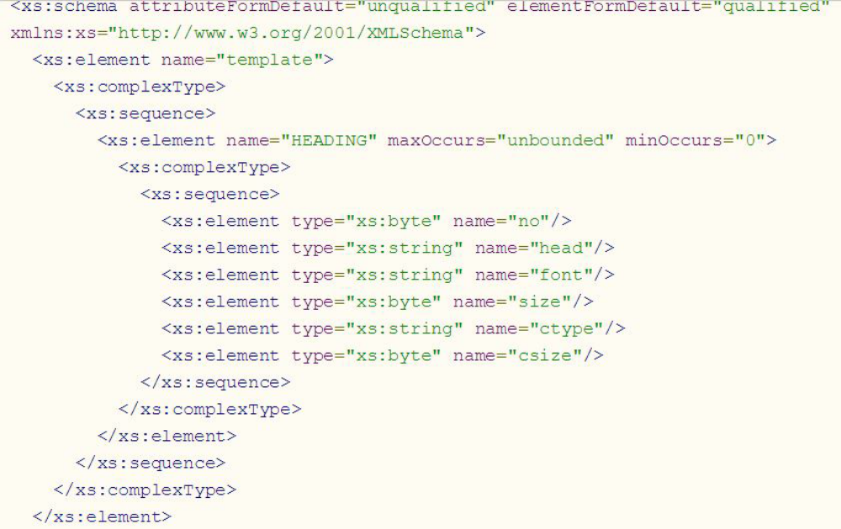
Figure 1 XML Schema

XML Comparison
Steps:
- Here the mapping of template with the document is done. Moreover the comparing of
xml files.
- Both xml files(template xml and document xml) are loaded.
- Heading from the template is loaded and checks for the same in the document xml.
- If found the heading properties are checked for similarity. Then the contents are
checked.

After the template and document XML generation, comparison is between XML files. Comparing semi-structured documents has gained increasing attention since these documents are light weight and easy to use, even though from different perspectives like the purpose of characterizing a document with regard to a given DTD. [2][8]. Here the priority goes to the template XML. Based on the template XML the document XML is evaluated. Headings from the template XML is taken and the document XML is traversed top to bottom for similar heading. If found, the heading number is stored temporarily. Then next step is to check for the similarity in properties like font size, font type, content font size, content font size.

Score Calculation

A variable for score is maintained throughout the comparisons. A score of 1 for every properties. That is one for each font size, font type, content font size, content font size. Then the total score of the document is calculated as.

(no of headings in template) * 5 (1)

Percentage of the calculated score obtained from xml comparison with the total score (1) is calculated. Project mentor sets a threshold there by deciding whether to accept or reject the document.

TAGGING AND CLUSTERING
Every project document is tagged on the basis of the academic years, research resource persons and research areas. This tags provides effective reference for future project groups. Tagging also gives a clear picture on the number of activities or projects done on a particular research area. These statistical data can be viewed as a report with charts and graphs depiction percentage of work happening in a research group.

Tagging
Steps:
1. On uploading a document the user selects the thrust area of the uploading file.
2. A new entry is added to the database with the filename and the tags corresponding to the thrust area.

Tags are the keywords or tokens which are given for each documents based on its thrust area. They are the set of possible words by which a topic is searched by a user. The very first step is to identify the possible search keyword for each thrust areas. Gather and save those keywords separately based on the thrust area. A database or a files can be used. Maximum number of keywords should be collected so that searching become more accurate. More the number of tags means more the success rate of relevant search result. Tagging is the way by which a project document is given a token of identification with the tag repository. That is, each uploaded document is mapped to a set of tags based on its thrust area.

Search

Steps
1. The word(s) entered by the user is passed to the server.
2. The keyword is searched in the entire tag database.
3. All the files under the selected tag is selected.
4. File is listed with a snippet of content from the file.

From the student’s perspective, this utility focuses on a reference bucket. It has a large data pool which contains the information and materials of the previous projects. The main difficulty of a student in the beginning of the project is to find out a right projects and a guide. Each faculty is focused on specific research/thrust areas and have different project experiences. With the search features, the students can easily find out a project guide which suits his area of interest.
All the uploads done by each project teams are stored in the document repository. Each of them are tagged to their corresponding tags based on their thrust area. Once a search query is initiated from a user, it is first cross checked with the tag repository. If a tag is matched then all the documents which are mapped onto that tag is listed as search result. For the convenience of the user, a snippet from the document is given along with each search results. It helps to choose the accurate document.

Results and Analysis:
The generated xml for each uploaded templates are stored for future purpose. The first window of the application shows an option to upload a new template for extraction or choose from the previous templates.
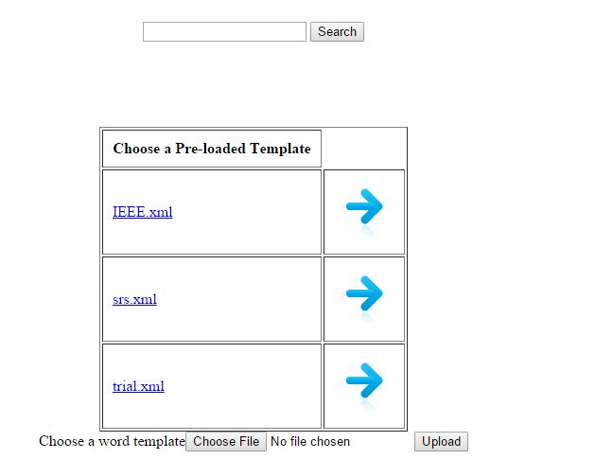
Figure 2 First Interface

Uploading and generating a new template is done as on request. The uploaded document is extracted as follows.
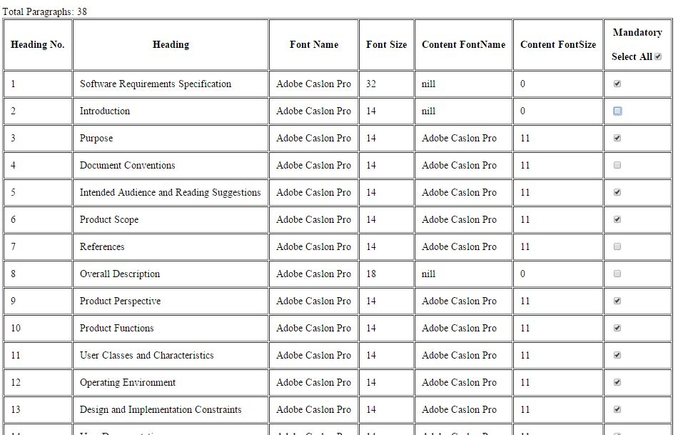
Figure 3 Generated Output

By selecting the mandatory elements, the generated template can be saved as XML.
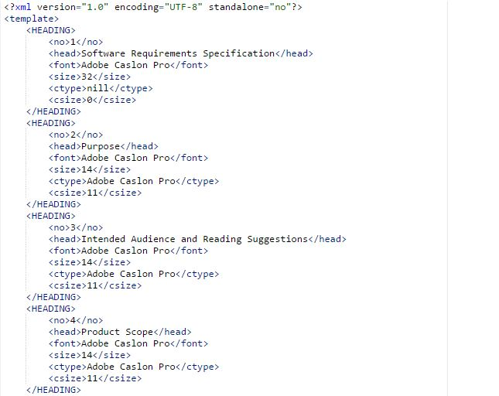
Figure 4 Generated XML

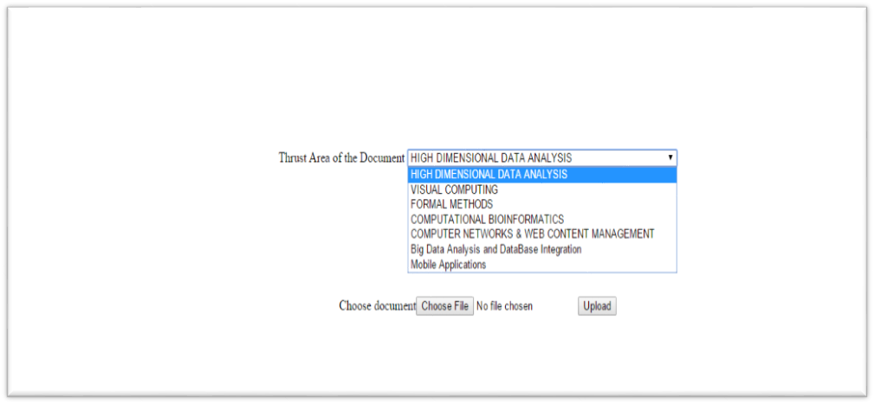
Figure 5 Uploading Document
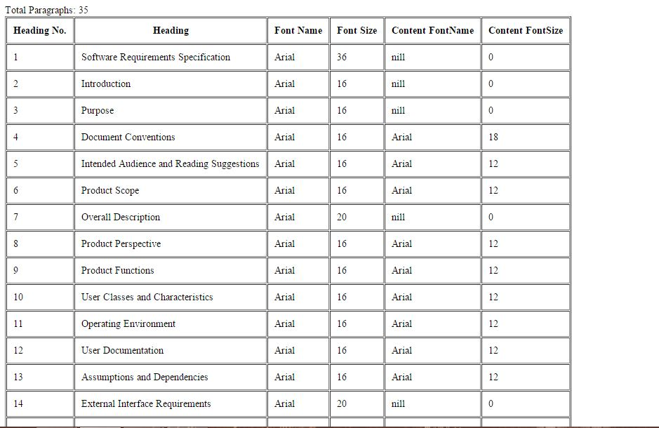
Figure 6 Document View

Now the document XML and the template XML are generated and ready for comparison.
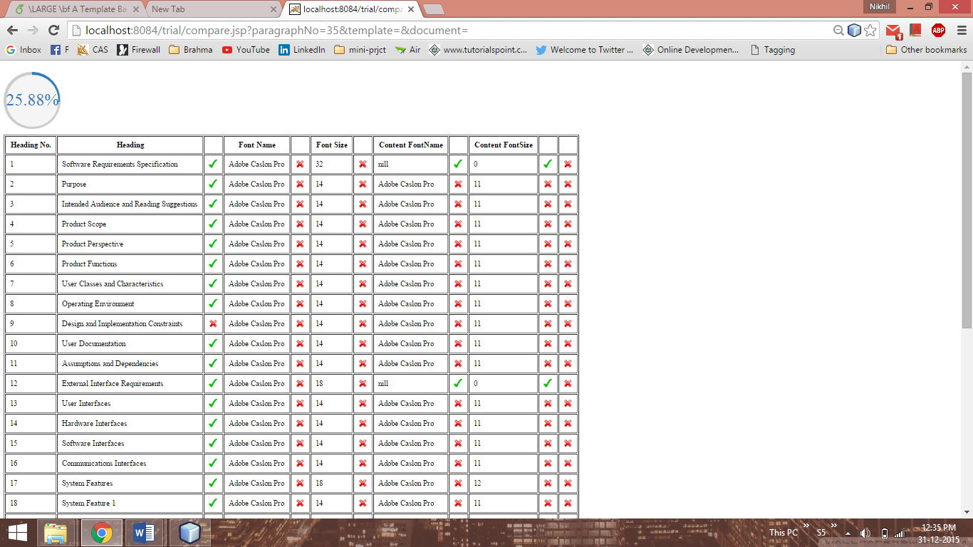
Figure 7 Output with Score
Searching for a document can be done by entering a search keyword. The system will list out all the related documents with a snippet of texts from the document.

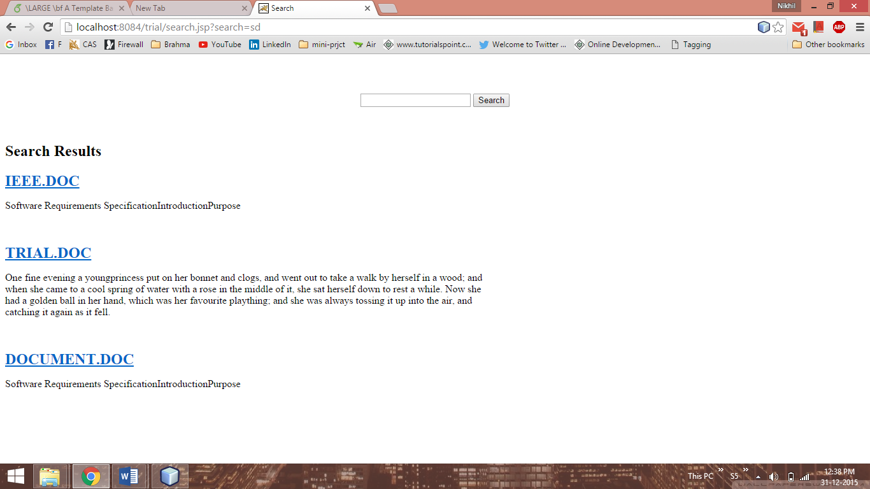
Figure 8 Sample Search Result

Conclusion & Future Work:
Applying various algorithms to mine the data pool tagging and clustering. There by the credibility of project documents are ensured. Introducing template based checking algorithm for the documents submitted by the students makes it easy for the project mentors to evaluate the documents in a few minutes with less strain. Algorithms that help in identifying the percentage of similarity with the template helps the above come true.
Future scope of this project is vast. The application can be used in any department irrespectively. A module for checking the plagiarism can be included so that the uniqueness of the documents are ensured. This module can be implemented with less effort because the documents are available in the document repository. Cross checking with them can do the job. The project can be extended to match the pixel similarities also. Pixel similarities includes the plagiarism detection in image files like Data Flow Diagram (DFD). The module template matching can also be enhanced by checking the more properties in documents. Properties like indent and line spacing, layout and orientation, alignments, margin size etc.

References:
[1] INDERJEET MANI ERIC BLOEDORN,Summarizing Similarities and Differences Among Related Documents, The MITRE Corporation, W640, 11493 Sunset Hills Road Reston, VA 22090, USA.
[2] JIANYING HU GORDON WILFONG, Comparison and Classification of Documents Based on Layout Similarity.
[3] K. McKeown and D. Radev. Generating Summaries of Multiple News Articles, Proceedings of ACMSIGIR95, Seattle, WA.
[4] G. Salton, J. Allan, C. Buckley and A. Singhal. Automatic Analysis, Theme Generation, and Summarization of Machine-Readable Texts, Science, 264, June 1994, pp. 1421-1426.
[5] Sundaram, Elango (2004-03-22), Excelling in Excel with Java, Java World
[6] ”Microsoft Eyes Open Source Components for Office 2007”. Information Week. 26 March 2008. Retrieved 1 March 2009.
[7] POI development mailing list archives, March 2008
[8] Fast Detection of XML Structural Similarity Sergio Flesca, Giuseppe Manco, Elio Masciari, Luigi Pontieri, and Andrea Pugliese, Student Member, IEEE
[9] Tagging and Why It Matters, David Weinberger, Research Publication No. 2005-07
May 2005
[10] Convergence of Web 2.0 and Semantic Web: A Semantic Tagging and
Searching System for Creating and Searching Blogs Gina Hope, Taehyung (George) Wang, and Shan Barkataki

